Undergraduate Psychology Organization (UPO) & Psi Chi Research Night
Sept. 12, 2016, 4pm
Current & Forthcoming Research Opportunities

Name: Dr. Rick Bevins (Graduate student: Brady Thompson)
Program/Agency/Lab: Behavioral Neuropharmacology Lab
Email Address:
Brady Thompson: brthomp1@gmail.com ; bthompson11@unl.edu
Office/Lab Location: Burnett Hall 19D
Phone Number: (402) 430-7188
Web Page: http://psychology.unl.edu/psychoneuropharm/home
Description of position (research topic, URA duties, etc.): Students get to assist on or help create studies looking at the behavioral effects of drugs using animal models. Students will be trained to administer drugs, handle animals in research settings, mix and make drug/non-drug solutions. While also being able to work alongside graduate students and post-doctorate researchers to gain research experience, learn about graduate studies, drugs, neuroscience, learning and behavior.
UCARE and Honors/Senior Thesis opportunities are available.

Name: Taylor English
Program/Agency/Lab: Comorbid Alcohol and Mental Illness (CAMI) Lab
Email Address: tenglish93@gmail.com
Office/Lab Location: Burnett 36 & 37
Phone Number: (251) 228-6017
Web Page: http://psychology.unl.edu/cami/
Description of position (research topic, URA duties, etc.): Looking for motivated research assistant to help with project examining the relationship between alcohol use, sleep problems, and academic performance in college students. Main duties will be helping to run participants and download sleep data gathered during participant sessions (Monday and Friday availability is a must). RA will also have opportunities to develop poster presentations at major conferences with the data gathered, as well as to gain experience writing manuscripts to be published in major journals. Being involved in the CAMI Lab will also expose the RA to invaluable information about graduate school and guidance through the admission process.

Name: Jeff Stevens (Graduate student: Juan Duque)
Program/Agency/Lab: Adaptive Decision Making Lab
Email Address: jeffrey.r.stevens@gmail.com
Office/Lab Location: CB3 B-level
Web Page: http://decisionslab.unl.edu
Description of position (research topic, URA duties, etc.): The human side of the Adaptive Decision Making Lab explores how and why we make the decisions that we do. We study
- patience
- impulsivity
- cooperation
- environmental decision making.
We’re looking for volunteer undergraduate research assistants to help collect data from participants for 6-10 hours per week.

Name: Juan F. Duque & Jeffrey R. Stevens
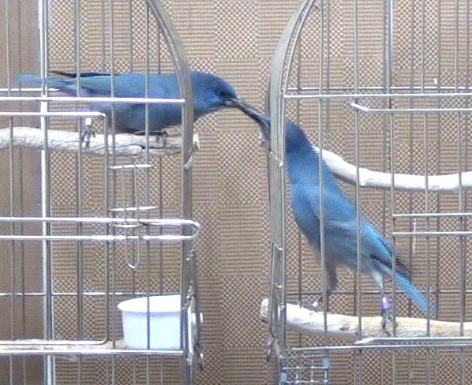
Program/Agency/Lab: Avian Cognition Lab / Adaptive Decision Making Lab
Email address: jfduque89@gmail.com
Lab Location: Birds are located by Manter 13 (basement: pictures of birds on door)
Web Page: http://www.decisionslab.org/
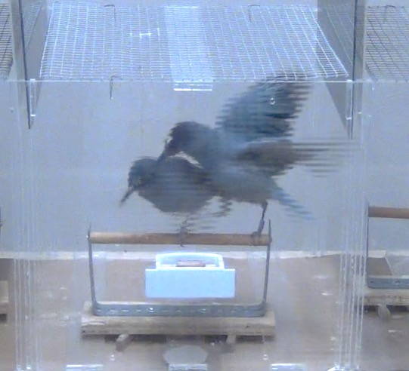
Description of position: Our lab seeks to integrate cognition (i.e. what goes on in an animal’s mind) with evolutionary perspectives like the natural history or behavioral ecology of the species, in the study of why and how animals make tough decisions. For example, why do pinyon jays beat the crap out of each other when competing for food as they establish a dominance hierarchy, but those same birds show cooperative behaviors like food sharing in other contexts? While these contexts both involve food, we see extreme differences in the way these birds interact. Our lab thus aims to understand how/why animals make decisions in different contexts by using a blend of psychology and biology.
Looking for 2-3 undergraduate students interested in animal behavior/cognition! The position would involve 6-12 hours per week. Depending on availability/interest, hands-on experience and individual projects are available.
Our animal lab currently focuses on the social and cooperative behaviors of three corvid species: Blue jays, Pinyon jays, and Blue jays. Previous work in our lab has studied the role of a dominance hierarchy and reciprocity on voluntary food sharing. Several possible projects, all involving aspects of avian cognition, are currently available including:
- running behavioral experiments (e.g., personality tasks: neophobia and risk-taking)
- video coding of behaviors,
- video analysis/audio extraction,
- sample collection for hormone analysis,
- animal husbandry (socializing/enriching)
- and more!

Name: Trace Vardsveen
Program/Agency/Lab: Law-Psych program; Legal Decision-Making Lab
Email Address: tvardsveen@huskers.unl.edu
Office/Lab Location: Room 21 in Burnett Hall
Description of position (research topic, URA duties, etc.): In need of undergraduate RA’s who will work on in-lab and field psycho-legal studies

Name: Dr. Eve Brank (Graduate student: Josh Haby)
Program/Agency/Lab: Law & Policy Lab
Email Address: BrankLab@gmail.com
Office/Lab Location: Burnett 57
Phone Number: (402) 472-3328
Web Page: http://psychology.unl.edu/ebrank/
Description of position (research topic, URA duties, etc.): This is a great lab for students interested in law school or psychology graduate school. Our current areas of interest include (but are not limited to) plea negotiations, Fourth Amendment and expectations of privacy, trial consulting, physiological response to risk-taking in legal decision-making, obesity laws, juveniles, parental responsibility/parental involvement, elder care giving and other elder issues. We aim for our RA experience to be interactive, fun, and worthwhile. We have positions available on a voluntary basis or for course credit. Paid positions may be available depending on research interests.

Name: Andrea Avila & Jessica Palmer-Bacon
Program/Agency/Lab: Clinical – Serious Mental Illness Research Group (Dr. William Spaulding’s lab)
Email Address: avila.andrea.n@gmail.com
Office/Lab Location: Variable
Phone Number: (832) 265-0241
Web Page: http://psychology.unl.edu/smi/welcome
Description of position (research topic, URA duties, etc.): Potentially help with data collection, entry, analysis, and/or presentation related to research on psychopathology and interventions to benefit people with serious mental illness.

Name: Kathy Chiou
Program/Agency/Lab: Clinical Neuroscience & Neuropsychology Lab
Email Address: kchiou2@unl.edu
Office/Lab Location: 218 Burnett
Web Page: TBD
Description of position (research topic, URA duties, etc.):
Our lab is interested in how cognitive processes are affected after traumatic brain injury. Specifically, we are examining metacognitive deficits—a type of self-awareness that involves online, in-the-moment monitoring of cognitive processes, in adults who have had a TBI. We utilize traditional cognitive assessments as well as neuroimaging techniques (fMRI and DTI) to identify behavioral and neural correlates of metacognition.

Students who have any interest in neuropsychology (study of brain and behavior), cognition, neuroimaging, brain injury or other neurological injury/disease, or neuroscience are all encouraged to apply. We are currently recruiting undergraduate research assistants and a part time lab manager. For the research assistant positions, students need to be able to dedicate at least 1.5-2 years to working in the lab. Research assistants will aid in participant recruitment, data collection, scoring and entering data, and pre-processing of neuroimaging data. The part-time lab manager would be an appropriate position for a recent graduate—or if there are any seniors who will be graduating soon and would like to gain research experience before applying for graduate programs.

Name: Dr. Rebecca Brock (Graduate students: Jennifer Blake & Kailee Groshans)
Program/Agency/Lab: Family Development Lab
Email Address: rebecca.brock@unl.edu
Office/Lab Location: 220 Burnett
Phone Number: (402) 472-7779
Web Page:
Lab: http://psychology.unl.edu/family-development-lab/
Faculty: http://psychology.unl.edu/rebecca-brock
Description of position (research topic, URA duties, etc.): The Family Development Lab, under the direction of Dr. Rebecca Brock, is currently seeking research assistants for the 2016-2017 academic year. The primary objective of the lab is to investigate the development of psychopathology (e.g., mood and anxiety disorders) across the lifespan with a focus on the family context and its etiological significance. Our research examines couple and family processes (e.g., conflict, support, warmth and closeness) across various stages of family development. Multi-method approaches are employed (questionnaires, clinical interviews, behavioral observations) to assess qualities of family relationships and the health and functioning of family members (adults and children). The research conducted in this lab informs the development of interventions aimed at preventing and treating individual psychopathology and comorbid family dysfunction.

The strongest candidates for a research assistantship will be psychology majors with a GPA greater than 3.5. Candidates with prior research experience (e.g., participant recruitment and retention, clinical interviewing, behavioral observation, data management, supervision of a research team) are preferred.

This assistantship is eligible for course credit. Members of the lab will receive training in couples and families research methods and will actively contribute to ongoing clinical research. Lab members may also be invited to present or publish their own lab-related research. Career mentorship (e.g., navigating graduate school applications) will be available. A major focus of the assistantship will be training in clinical interviewing which may be of particular interest to those planning to pursue a graduate education in clinical or counseling psychology.

Name: Dr. David Hansen (Graduate student: Jessie Pogue)
Program/Agency/Lab: Clinical Psychology Training Program/ Child Maltreatment Lab
Email Address: unlcmlab@gmail.com
Office/Lab Location: 45 & 46 Burnett Hall; Child Advocacy Center, 5025 Garland Street, Lincoln, NE 68504; Community Action Partnership, 210 West O St, Lincoln, NE, 68508

Web Page: http://psychology.unl.edu/childmaltreatmentlab/home; more information about the Child Advocacy Center can be found at www.smallvoices.org
Description of position (research topic, URA duties, etc.):
The Child Maltreatment Lab is looking for research assistants to help with research efforts at Project SAFE (Sexual Abuse Family Education), an ongoing project with treatment seeking participants at the Child Advocacy Center and with Early Head Start/Head Start at Community Action Partnership. The Child Maltreatment Lab accepts students on an ongoing basis throughout the year.
Project SAFE is a standardized mental health treatment program for sexually abused youth and their non-offending family members that includes group and individual treatment. The Child Maltreatment Lab regularly recruits research assistants to help with coding, scoring, and entering assessment data that is collected from Project SAFE participants. Additionally, research assistants are provided opportunities for face-to-face contact with participants at the Child Advocacy Center (CAC), where Project SAFE clinical activities are held. The CAC is a non-profit organization that provides a safe and child-friendly environment for conducting investigative procedures and advocacy for abused children. Common activities at the CAC include greeting families, assisting in data collection, and providing childcare while parents and caregivers participate in services.
The Child Maltreatment Lab provides mental health services to children and families enrolled in Early Head Start/Head Start, and consultation services to program and classroom staff. Clinical and research efforts focus on strategies for early identification and prevention of maltreatment and early intervention for other risks to healthy child development. The Child Maltreatment Lab recruits research assistants to help with entering assessment and clinical data that is collected from participants.
Undergraduate research assistants who volunteer with the Child Maltreatment Lab become familiar with assessment measures often used for both clinical and research purposes, learn to hand score assessment measures including the calculation of t-scores, and practice data entry into SPSS software. Prior and current URA’s in the Child Maltreatment Lab have been successful in receiving UCARE funds and having poster presentations accepted at regional and national conferences. The Child Maltreatment Lab values strong mentorship and provides guidance in navigating the graduate applications process.

Name: Annie Steel (Doctoral student in the Clinical Psychology Training Program)
Program/Agency/Lab: Trauma, Violence, and Abuse Lab (Advisor: David DiLillo, Ph.D.)
Email Address: asteel@huskers.unl.edu
Office/Lab Location: 53 Burnett Hall
Phone Number: (304) 633-1322
Web Page: http://psychology.unl.edu/tvalab/
Description of position (research topic, URA duties, etc.):
What is the project?
I am currently collecting data for my dissertation study “Responding to a Social Situation Involving a Close Friend.” The goal of this study is to examine the influence of victim- and perpetrator-related factors on individuals’ responses to a sexual risk situation as well as a victim’s disclosure of sexual assault. Participants complete two surveys online. At each time point, participants are presented with a hypothetical vignette (i.e., story) and are asked to answer a number of questions about it.

Why should I join the research team?
Sexual assault on college campuses is highly prevalent and has serious mental and physical health consequences for victims. My dissertation study adopts a novel approach to better understand how college student bystanders—like yourselves—might be able to intervene to prevent or minimize the negative consequences of sexual assault. Thus, as an undergraduate research assistant (URA) on this project, you would have the opportunity to participate in cutting edge research about a topic that is highly relevant to you and your peers.

What will undergraduate research assistants on this project do?
URAs on this project will work together as a research team to generate the data that will ultimately allow me to address my primary research questions. Specifically, URAs will use a coding system to analyze participants’ written responses to a hypothetical sexual assault disclosure. This coding system assesses dimensions of both positive and negative reactions to disclosure (e.g., providing emotional support, blaming the victim). Prior to coding, I will carefully train URAs on the reliable use of the coding system.

As a member of the research team, you would also participate in weekly lab meetings. During these meetings, we will not only review your progress on the project but will also discuss topics relevant to the field of interpersonal violence and trauma. We will also periodically discuss academic and professional development (e.g., applying to graduate school, career options in psychology). URAs on this project will be asked to commit to approximately 3-5 hours/week.

Name: Mario Scalora, Ph.D.
Program/Agency/Lab: Targeted Violence Research Lab
Email Address: mscalora1@unl.edu
Office/Lab Location: 337 Burnett
Phone Number: (402) 472-3126
Web Page: http://psychology.unl.edu/targeted-violence/
Description of position (research topic, URA duties, etc.): Undergraduate assistance is requested to assist with multiple research projects within the Targeted Violence Research Team. This team is chaired by Dr. Mario Scalora, a forensic psychologist, and staffed by his graduate students. The research projects address a range of issues including: stalking, terrorism and political extremism, sexual violence and campus violence. Research assistants will be asked to assist with data entry, management and collection activity. This lab provides a unique opportunity to extract data from sources not typically available to researchers within the criminal justice and forensic mental health systems. In addition to learning about the research process from a hands-on perspective, the research assistants will have the opportunity to be exposed to various aspects of violence assessment and management.
Given the sensitive nature of the data involved, all assistants will be required to pass a criminal history check before participation.

